OX-ZT412G
4G Helmet Camera
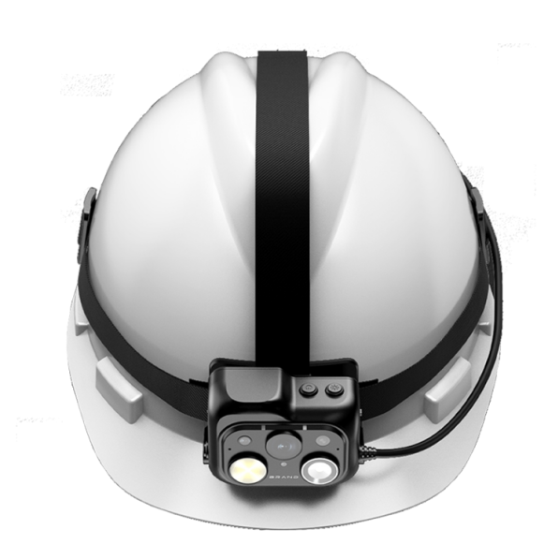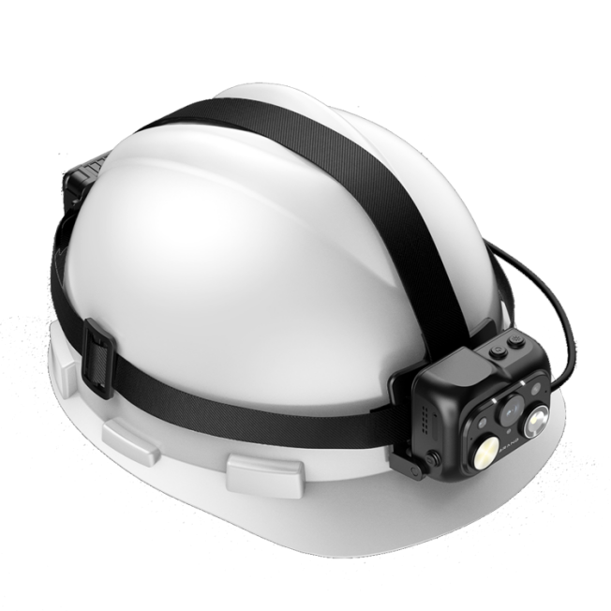
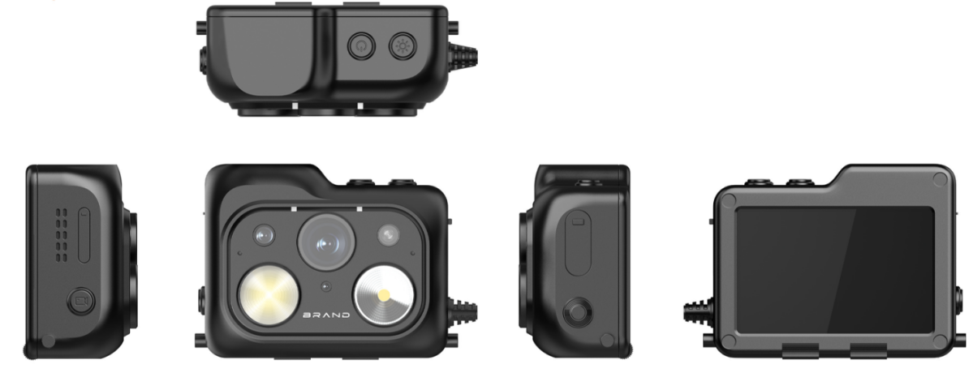

- Features
High Level Protection
-IP66, adaptive to various environments
-2 meters drop protection
Excellent Video Transmission
-4G / Wi-Fi transmission, improves the video stream continuity under unstable network conditions
-H.264 / H.265 video codec, saves up to 50% bandwidth and storage
High Quality Image
- Up to 2K HD video quality, 2560 x 1440p @ 30fps
- Higher resolution camera, supports up to 64M
Professional lighting features
-Flashlight flood mode reaches 125lm
-Flashlight spot mode reaches 80lm
Abundant Functions and Features
-2.0” IPS touchscreen display
-Gesture lighting control
-Dual-camera design with fixed focus and zoom modes
-Starlight night vision main camera for clearer nighttime video
-140 degree wide-angle camera
Multimedia function:
-Support cluster PTT intercom
-Support functions such as video recording, QR code scanning, TTS, etc
-Support file upload to cloud servers and support breakpoint resume function
-Support AI algorithms such as facial recognition, license plate recognition, etc

Specifications
Model | OX-ZT412G
Operation System | Operation System | Android 12.0
CPU | CPU | MT6769 8 Cores CPU 64 bit, 2.0GHz.
Memory | RAM+ROM | 3GB+32GB by default(optional 4GB+64GB/4GB+128GB/4GB+256GB)
Main Lens (1st) | Image Sensor | 1/3" progressive scan CMOS
Main Lens (1st) | Max. Recording Resolution | 2560 × 1440
Main Lens (1st) | FOV | ≧ 140°
Main Lens (1st) | Focal Length | 1.9 mm fixed lens
Main Lens (1st) | Aperture | 2.3±5%
2nd Lens | 2nd Lens | 8 million AF
Video | Video Compression | H.264, H.265
Video | Main Stream | 2560×1440/30fps, 1920×1080/30fps, 1280×720/30fps, 640×480/30fps
Video | Sub-Stream | 2560×1440/30fps, 1920×1080/30fps, 1280×720/30fps, 640×480/30fps
Video | Video Format | MP4, PS
Video | Pre-record & Post-record | Pre-record: 60/10/5/3s,(Optional)
Video | Pre-record & Post-record | Post-record: 60/10/5/3s(Optional)
Image | Resolution | 64M, 48M, 32M, 16M, 8M, 4M
Image | Image Format | JPEG
Audio | Audio Compression for Video Recording | AAC, G711
Audio | Audio Compression for Audio Recording | MP3,AMR,WAE
Audio | Audio Compression for Group Intercom | OPUS,G711
Audio | Audio Bit Rate | AMR (12 kbps), AAC (128 kbps), MP3 (128 kbps), G711 (192 kbps),OPUS(13 kbps)
Screen | Screen Size | 2.0"
Screen | Touchscreen | Supported
Screen | Display Resolution | 640 × 480
Screen | Screen Brightness | Typical value: 350 cd/m²
Lighting function | Professional lighting | Flashlight flood mode reaches 125lm,Flashlight spot mode reaches 80lm
Lighting function | Laser Lighting | Supports laser positioning
Lighting function | Gesture lighting | Supported
Network Parameters | Wireless Network | 2.4G/5.8G Wifi 5 ac, support IEEE802.11 ac/a/b/g/n
Network Parameters | Bluetooth | BT5.0
Network Parameters | Positioning Mode | GPS
Network Parameters | 4G | LTE FDD: B1/B2/B3/B4/B5/B7/B8/B20/B28A
Network Parameters | 4G | LTE TDD: B34/B38/B39/B40/B41
Network Parameters | 4G | WCDMA：B1/B5/B8
Others Parameters | Gyroscope | Built in
Others Parameters | G-Sensor | Built in
Network Protocol | Protocol | RTSP, Onvif, MCS8, FTP
Network Protocol | API | SDK
Security | Encryption | AES256
Security | Watermark | Supported
Software Functions | Smart Functions | Face Picture Capture(Optional)
Software Functions | Smart Functions | Face Picture Recognition(Optional)
Software Functions | Smart Functions | License Plate Recognition(Optional)
Software Functions | Basic Event | SOS alarm
Software Functions | Group Intercom | Supported
Software Functions | Voice Broadcast | Supports TTS voice broadcast(Optional)
Software Functions | File Upload | Supports OSS object storage and file upload
Software Functions | Video Intercom | Supports video calls between multiple devices(Optional)
Software Functions | Voice Call | Supports voice calls between multiple devices(Optional)
Software Functions | Message Delivery | Supports platform-to-device messaging of messages, files, and other content(Optional)
Software Functions | Software Upgrade | Supports OTA firmware or app upgrades
Battery | Battery Life | Up to 10 hours in 1080p resolution¹
Battery | Charging Way | Type C
Battery | Capacity | 4000mAh
Battery | Battery Type | Lithium-ion battery
Battery | Charging Time | ≤ 4 h
General | Power | 5 V DC, 2.0 A
General | Charging Interface | Type-C, Pogo Pin
General | Mic | 2 built-in mic(s)
General | Speaker | 1 speaker(s),max. power consumption: 1.5 W
General | USB | Type-C
General | SIM Card | 1 Nano-SIM card(s)
General | TF Card | 1 TF card(s),64 /128/256 /512GB optional
General | Button | LED Light, Power on/off, Video recording
General | Dimensions | 69.3 x 55 x 28mm
General | Weight | 220g
General | Operating Temperature | -20℃～+55℃
General | Operating humidity | 40%-90%
General | Protection Level | IP66
General | Anti-drop level | 2M
Warranty | Warranty | 1 year
- This is a basic estimation of battery working life only when recording is on. Additional power consumption should be considered when IR, GPS, and/or network connection is on
- All battery claims depend on network configuration and many other factors, actual results will vary.
- Product parameters may vary, please refer to the actual product.

